Program |  | B.Tech. (Computer Science & Engineering) |  |  |  |  |  | Semester |  | IV
Course |  | WebX Design and Development Lab |  |  |  |  |  | Code |  | ---
 |  | Teaching Scheme (Hrs/Week) |  |  | Examination Scheme & Marks
Credits |  | Lectures | Tutorials | Practical | CA |  | TEA |  |  |  | Total
 |  |  |  |  | Theory | Practical | Theory |  | Practical |  | Total
2 |  | -- | -- | 4 | -- | -- | -- |  | 25 |  | 25
Prerequisite:
1) Problem Solving through Programming.
Other Courses in this Series:
1) Advanced Programming in WebX
Course Objectives:
- To provide fundamental knowledge of web technologies and structured web development.
- To enable students to develop dynamic and interactive web applications using modern frameworks.
- To integrate backend services and databases for secure and scalable web applications.
- To introduce deployment, security practices, and performance optimization in web applications.
Course Outcomes:
On completion of the course, students will be able to:
CO1: Develop structured and responsive web pages using HTML, CSS, and JavaScript. CO2: Build dynamic web applications using JavaScript frameworks and API integration. CO3: Implement backend integration and database connectivity for secure web applications.
CO4: Deploy and manage web applications with proper configuration and optimized performance.
Sr.  No. | Group-A (Unit-1 Fundamentals of Web Technology)
1 | - Online Library System – Develop a responsive webpage to display books description in table.  - Event Registration System – Create an online form for seamless event registrations.  - Personal Portfolio Website – Design a structured, mobile-friendly personal portfolio.  - Feedback Form Page-Create a basic feedback form using HTML form elements and CSS styling.

Lab Assignment No: Group A-1
Name of Student : Aaditya Patil
Roll No:25SC135 Div :A

Title: Online Library System

Problem Statement: Develop a responsive webpage to display book descriptions in table.

Aim: To create and run a responsive Online Library System webpage with HTML and CSS, which will display book descriptions in a table format. The major goal is to ensure it has the right structure, is easy to read, and works well on different devices.

Algorithm:

- Start
- Create an HTML document using the <html> tag.
- Define the webpage title and viewport settings inside the <head> section.
- Apply CSS styles to:
  - Set font, background color, and layout
  - Design a responsive table using width, border-collapse, and overflow-x
- Create a heading for the webpage using <h1>.
- Use a <table> element to display book details.
- Add table headings using <th> for:
  - Book ID
  - Title
  - Author
  - Category
  - Year
  - Status
- Insert book records using <tr> and <td> tags.
- Apply conditional styling for availability status (Available / Issued).
- Save the file with .html extension.

- Open the file in a web browser to view the output.
- Stop
Student’s Work: (Structure)

Expected Output:
- A responsive Online Library System webpage should be displayed.
- The page html page should show a table of books with columns such as Book ID, Title, Author, Category, Year, and Status.
- The table adjusts to different screen sizes. On smaller screens, horizontal scrolling is enabled for better readability.
- Book availability is visually differentiated using different colours to the text:
  - Green colour for Available books
  - Red colour for Issued books
- The interface is user-friendly and well-structured.

Output:
When the HTML file is opened in a browser, the library book table is displayed successfully without errors.

Screenshots:

- home.html

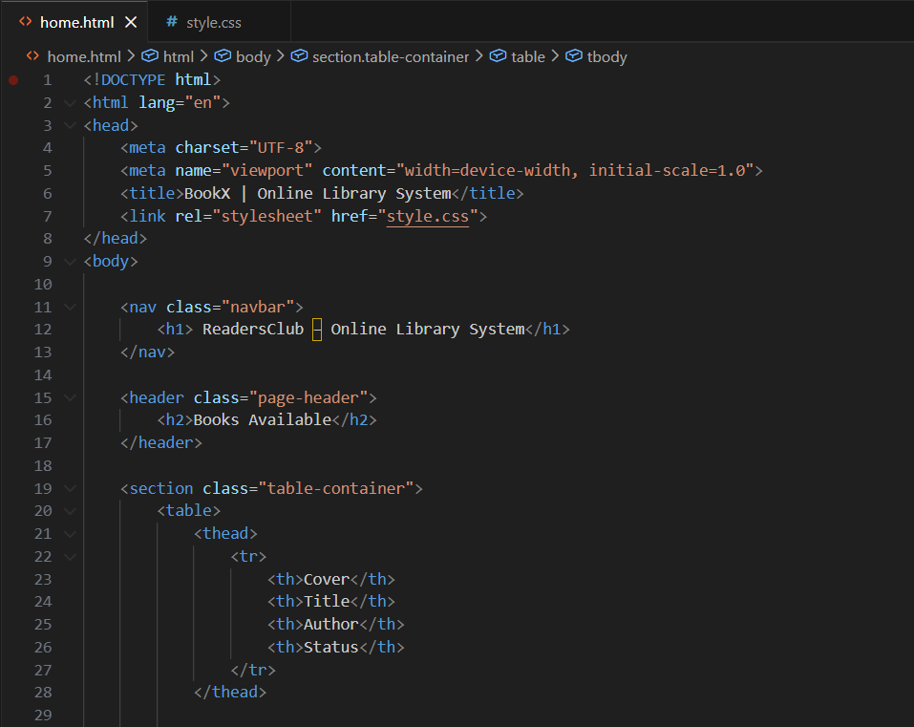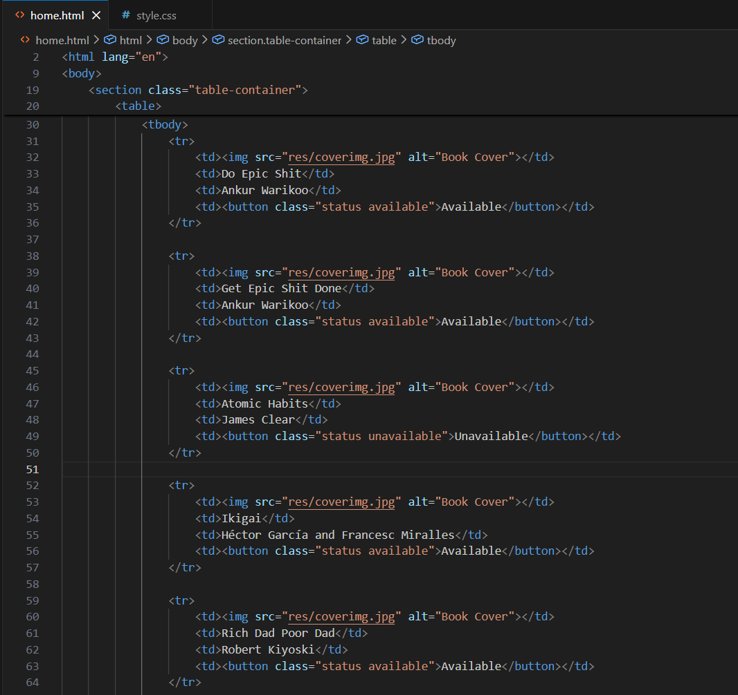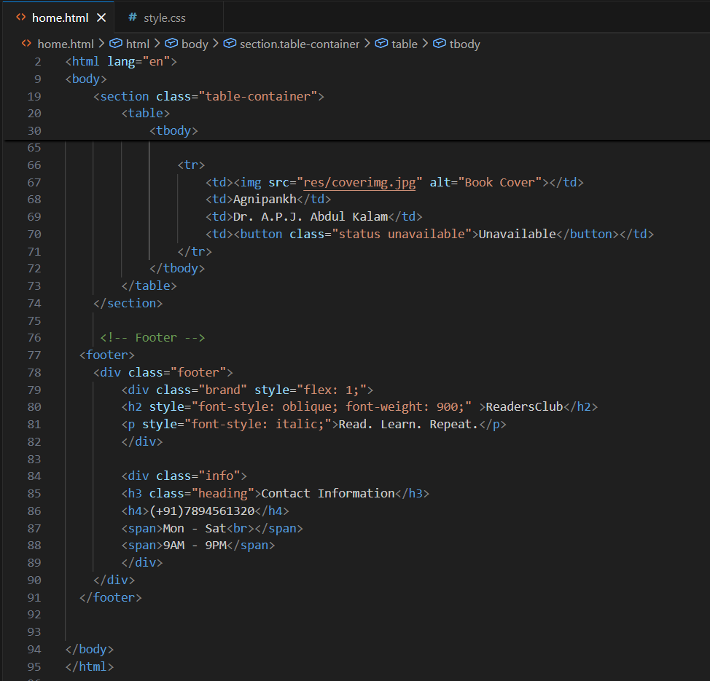

- Style.css
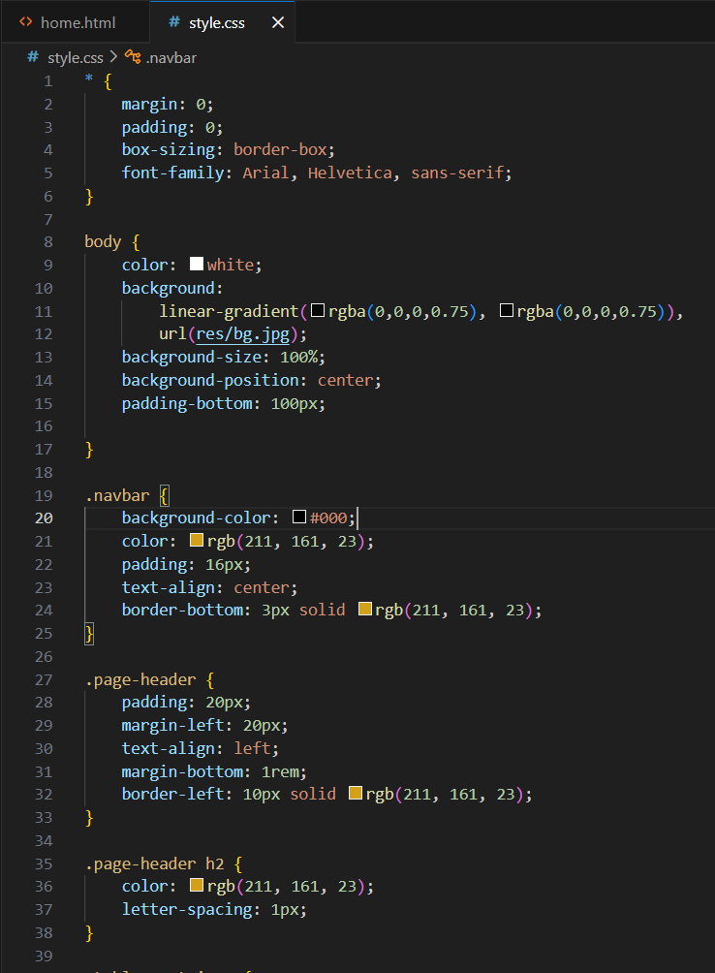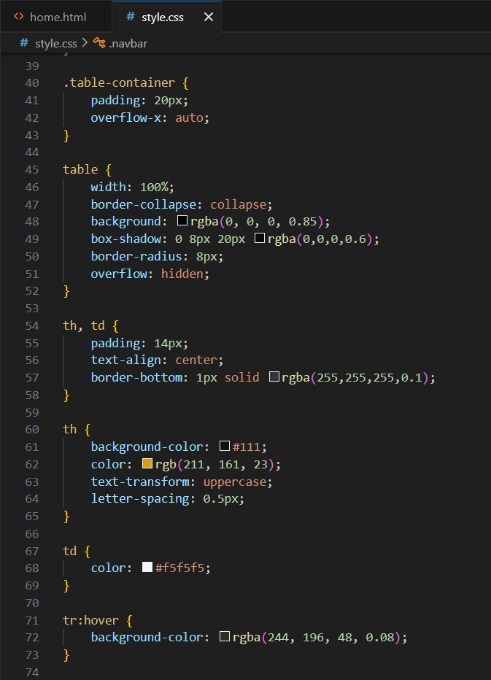
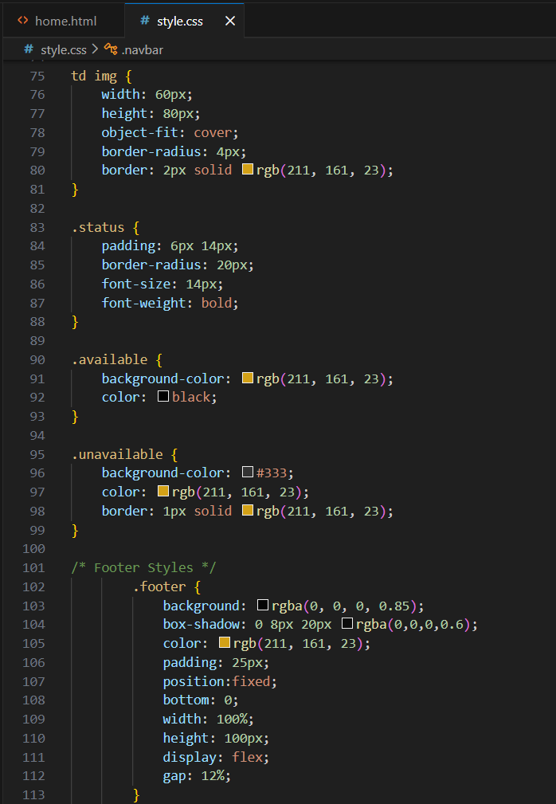

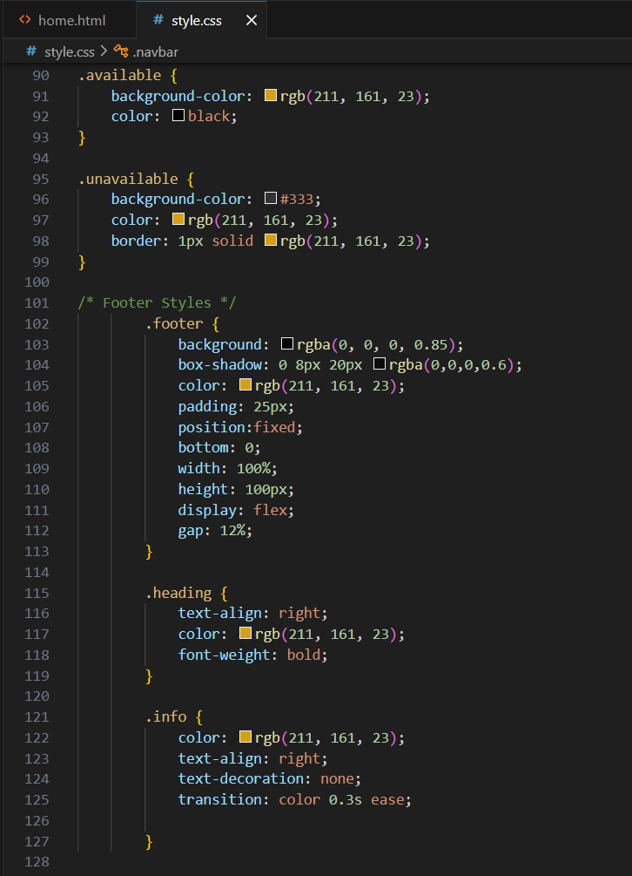

Output
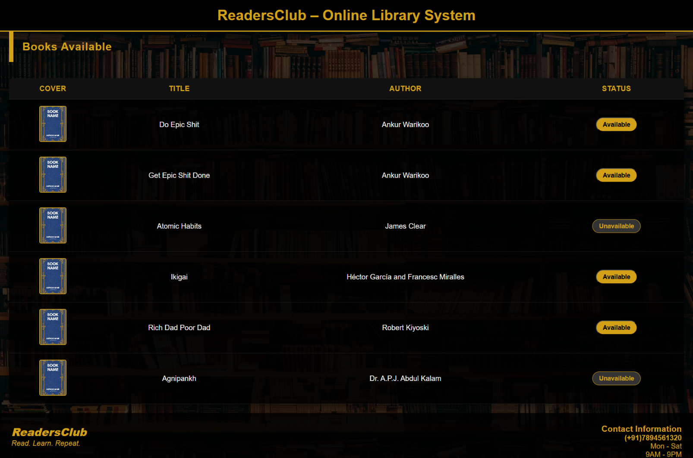

GitHub Repository Link:
https://github.com/Aadityx/ReadersClub

Key Learning:
- Implemented Table in html to display book information.
- Added footer to the webpage to make it look professional.
- Implementation of Flexbox in footer to display text row-wise.
- Box Shadowing of table for better animations.
- Hovering Effect on table and status button.
- Placing footer to bottom of website using positioning in css.

